CCNAv7 ITN Skills Assessment – ITN Final Skills Exam (Equipment)

Your exam may be different

Topology
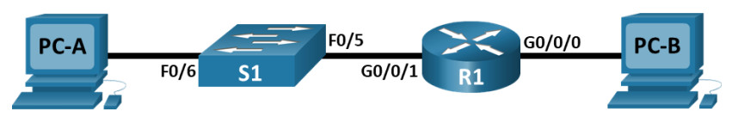
CCNAv7 ITN Skills Assessment

Assessment Objectives
- Part 1: Develop an IP Addressing Scheme (20 points, 25 minutes)
- Part 2: Initialize and Reload Devices (10 points, 20 minutes)
- Part 3: Configure Device IP address and Security Settings (45 points, 35 minutes)
- Part 4: Test and Verify IPv4 and IPv6 End-to-End Connectivity (15 points, 20 minutes)
- Part 5: Use the IOS CLI to Gather Device Information (10 points, 10 minutes)

Scenario
In this Skills Assessment (SA) you will configure the devices in a small network. You must configure a router, switch and PCs to support both IPv4 and IPv6 connectivity. You will configure security, including SSH, on the router. In addition, you will test and document the network using common CLI commands.

Required Resources
- 1 Router (Cisco 4221 with Cisco IOS XE Release 16.9.4 universal image or comparable)
- 1 Switch (Cisco 2960 with Cisco IOS Release 15.2(2) lanbasek9 image or comparable)
- 2 PCs (Windows with a terminal emulation program, such as Tera Term)
- Console cables to configure the Cisco IOS devices via the console ports
- Ethernet cables as shown in the topology

Instructions

Part 1: Develop an IP Addressing Scheme
- Total points: 20
- Time: 25 minutes
a. Your instructor will assign one of the IPv4 networks from the table below. You will subnet it to provide IP addresses to two subnets that will support the required number of hosts. No subnet calculators may be used. All work must be shown using the IP Addressing worksheet below.
Network | Number of Hosts in Subnet A | Number of Hosts in Subnet B
192.168.10.0/24 | 100 | 50
172.16.1.0/25 | 60 | 20
209.165.201.0/27 | 12 | 5
IP Addressing Worksheet
- Type 1
- Type 2
- Type 3
Specification | Subnet A | Subnet B
Number of bits in the subnet | 25 | 26
IP mask (binary) | 11111111.11111111.  11111111.10000000 | 11111111.11111111.  11111111.11000000
New IP mask (decimal) | 255.255.255.128 | 255.255.255.192
Maximum number of usable subnets (including the 0th subnet) | 2 | 4
Number of usable hosts per subnet | 126 | 62
IP Subnet | 192.168.10.0 | 192.168.10.128
First IP Host address | 192.168.10.1 | 192.168.10.129
Last IP Host address | 192.168.10.126 | 192.168.10.190
b. Record your subnet assignment in the table below.
- 1) Assign the first IPv4 address of each subnet to a router interface
  - (i) subnet A is hosted on R1 G0/0/1
  - (ii) subnet B is hosted on R1 G0/0/0
- 2) Assign the last IPv4 address of each subnet to the PC NIC
- 3) Assign the second IPv4 address of subnet A to S1
- 4) List the maximum number of useable hosts per subnet
Description | Subnet A | Subnet B
First IP address | 192.168.10.1 | 192.168.10.129
Last IP address | 192.168.10.126 | 192.168.10.190
Maximum number of hosts | 126 | 62
c. Record the IP address information for each device:
Device | IP address | Subnet Mask | Gateway | Points
PC-A | 192.168.10.126 | 255.255.255.128 | 192.168.10.1 | 2 points
R1-G0/0/0 | 192.168.10.129 | 255.255.255.192 | N/A | 2 points
R1-G0/0/1 | 192.168.10.1 | 255.255.255.128 | N/A | 2 points
S1 | 192.168.10.2 | 192.168.10.1 | 255.255.255.128 | 2 points
PC-B | 192.168.10.190 | 255.255.255.192 | 192.168.10.129 | 2 points
d. Use the IPv6 address 2001:db8:acad::/48 and create two subnets for use in this network. Record the IPv6 addresses in the table.
Assigned to Interface | IPv6 Subnet Address | Prefix Length
G0/0/1 | 2001:db8:acad:a::/64 | 64
G0/0/0 | 2001:db8:acad:b::/64 | 64
e. Record the IPv6 address information for each device.
Note: Use FE80::1 as the link-local address on both router interfaces.
Device | IPv6 address | Prefix Length | Gateway | Points
R1-G0/0/0 | 2001:db8:acad:b::1 | 64 | N/A | 3 pts
R1-G0/0/1 | 2001:db8:acad:a::1 | 64 | N/A | 3 pts
S1 | 2001:db8:acad:a::2 | 64 | 2001:db8:acad:a::1 | 4 pts
Before proceeding, verify your IP addressing scheme with the instructor.
Instructor Sign-off Part 1:
Instructor Sign-off
Total Points for Part 1 (20 points):
Enter score here.

Part 2: Initialize and Reload Devices
- Total points: 10
- Time: 20 minutes
- Erase the startup configurations and VLANs from the router and switch and reload the devices.
On Switch
- Switch>enable
- Switch#erase startup-config
- Erasing the nvram filesystem will remove all configuration files! Continue? [confirm]
- [OK]
- Erase of nvram: complete
- %SYS-7-NV_BLOCK_INIT: Initialized the geometry of nvram
- Switch#delete vlan.dat
- Switch#reload
Proceed with reload? [confirm]
On Router
Router>enable
Router#erase startup-config
Erasing the nvram filesystem will remove all configuration files! Continue? [confirm]
[OK]
Erase of nvram: complete
%SYS-7-NV_BLOCK_INIT: Initialized the geometry of nvram
Router#reload
Proceed with reload? [confirm]
Initializing Hardware ...

Would you like to enter the initial configuration dialog? [yes/no]: no
- After the switch is reloaded, change the SDM template to one that supports IPv6 as necessary, and reload the switch again.
On Switch:
- Switch>
- Switch>enable
- Switch#configure terminal

- Switch(config)#sdm prefer dual-ipv4-and-ipv6 default
- Changes to the running SDM preferences have been stored, but cannot take effect until the next reload.
- Use 'show sdm prefer' to see what SDM preference is currently active.
- Switch(config)#exit

Switch#reload
Before proceeding, ask your instructor verify device initializations.
Instructor Sign-off Part 2:
Instructor Sign-off
Total points (10 points):
Enter score here.

Part 3: Configure Device IP Address and Security Settings
- Total points: 45
- Time: 35 minutes

Step 1: Configure R1.
Configuration tasks for R1 include the following:
Task | Specification | Points
Disable DNS lookup
Router name | R1 | 1 point
Domain name | ccna-lab.com | 1 point
Encrypted privileged EXEC password | ciscoenpass | 1 point
Console access password | ciscoconpass | 1 point
Set the minimum length for passwords | 10 characters | 2 points
Create an administrative user in the local  database | Username: admin  Password: admin1pass | 2 points
Set login on vty lines to use local database |  | 1 point
Set vty lines to accept SSH connections  only |  | 1 point
Encrypt the clear text passwords |  | 1 point
Configure an MOTD Banner |  | 1 point
Enable IPv6 Routing |  | 1 point
Configure Interface G0/0/0 | Set the description  Set the Layer 3 IPv4 address  Set the IPv6 Link Local Address as FE80::1  Set the Layer 3 IPv6 address  Activate Interface | 6 points
Configure Interface G0/0/1 | Set the description  Set the Layer 3 IPv4 address  Set the IPv6 Link Local Address as FE80::1  Set the Layer 3 IPv6 address  Activate Interface | 6 points
Generate an RSA crypto key | 1024 bits modulus | 2 points
On Router
Router>enable
Router#configure terminal

Router(config)#no ip domain lookup

Router(config)#hostname R1

R1(config)#ip domain-name ccna-lab.com

R1(config)#enable secret ciscoenpass

R1(config)#line console 0

R1(config-line)#password ciscoconpass
R1(config-line)#login
R1(config-line)#exit

R1(config)#security passwords min-length 10

R1(config)#username admin secret admin1pass

R1(config)#line vty 0 15
R1(config-line)#login local
R1(config-line)#transport input ssh
R1(config-line)#exit

R1(config)#service password-encryption

R1(config)#banner motd #Unauthorized Access is Prohibited!#

R1(config)# ipv6 unicast-routing

R1(config)#interface g0/0/0
R1(config-if)#description Connect to Subnet B
R1(config-if)#ip address 192.168.10.129 255.255.255.192
R1(config-if)#ipv6 address FE80::1 link-local
R1(config-if)#ipv6 address 2001:db8:acad:b::1/64
R1(config-if)#no shutdown
R1(config-if)#exit

R1(config)#interface g0/0/1
R1(config-if)#description Connect to Subnet A
R1(config-if)#ip address 192.168.10.1 255.255.255.128
R1(config-if)#ipv6 address FE80::1 link-local
R1(config-if)#ipv6 address 2001:db8:acad:a::1/64
R1(config-if)#no shutdown
R1(config-if)#exit

R1(config)#crypto key generate rsa
The name for the keys will be: R1.ccna-lab.com
Choose the size of the key modulus in the range of 360 to 2048 for your
General Purpose Keys. Choosing a key modulus greater than 512 may take
a few minutes.

How many bits in the modulus [512]: 1024
% Generating 1024 bit RSA keys, keys will be non-exportable...[OK]

Step 2: Configure S1.
Configuration tasks for S1 include the following:
Task | Specification | Points
Disable DNS lookup |  | 1 point
Switch name | S1 | 1 point
Domain name | ccna-lab.com | 1 point
Encrypted privileged EXEC password | ciscoenpass | 1 point
Console access password | ciscoconpass | 1 point
Shutdown all unused interfaces | F0/1-4, F0/7-24, G0/1-2 | 1 point
Create an administrative user in the local  database | Username: admin  Password: admin1pass | 1 point
Set login on vty lines to use local database |  | 1 point
Set vty lines to accept SSH connections only |  | 1 point
Encrypt the clear text passwords |  | 1 point
Configure an MOTD Banner |  | 1 point
Generate an RSA crypto key | 1024 bits modulus | 2 points
Configure Management Interface (SVI) on  VLAN1 | Set the description  Set the Layer 3 IPv4 address  Set the IPv6 Link Local Address as FE80::2  Set the Layer 3 IPv6 address | 2 points
Switch>enable
Switch#configure terminal

Switch(config)#no ip domain lookup

Switch(config)#hostname S1

S1(config)#ip domain-name ccna-lab.com

S1(config)#enable secret ciscoenpass

S1(config)#line console 0
S1(config-line)#password ciscoconpass
S1(config-line)#login
S1(config-line)#exit

S1(config)#interface range f0/1-4, f0/7-24, g0/1-2
S1(config-if-range)#shutdown

S1(config)#username admin secret admin1pass

S1(config)#line vty 0 15
S1(config-line)#login local
S1(config-line)#transport input ssh
S1(config-line)#exit

S1(config)#service password-encryption

S1(config)#banner motd #Unauthorized Access is Prohibited!#

S1(config)#crypto key generate rsa
The name for the keys will be: S1.ccna-lab.com
Choose the size of the key modulus in the range of 360 to 2048 for your
General Purpose Keys. Choosing a key modulus greater than 512 may take
a few minutes.

How many bits in the modulus [512]: 1024
% Generating 1024 bit RSA keys, keys will be non-exportable...[OK]

S1(config)#interface vlan 1
S1(config-if)#description Switch Subnet A
S1(config-if)#ip address 192.168.10.2 255.255.255.128
S1(config-if)#ipv6 address FE80::2 link-local
S1(config-if)#ipv6 address 2001:db8:acad:a::2/64
S1(config-if)#no shutdown
S1(config-if)#exit

S1(config)#ip default-gateway 192.168.10.1

Step 3: Configure host computers.
After configuring each host computer, record the host network settings with the ipconfig /all command. (2 points)
PC-A Network Configuration (1 point)
Description
Physical Address | 00E0.F9BB.3B05
IPv4 Address | 192.168.10.126
Subnet Mask | 255.255.255.128
IPv4 Default Gateway | 192.168.10.1
IPv6 Address | 2001:DB8:ACAD:A::A
IPv6 Default Gateway | FE80::1
PC-A
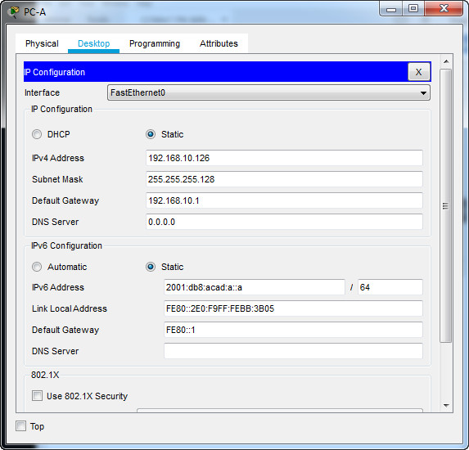

C:\>ipconfig /all

FastEthernet0 Connection:(default port)

Connection-specific DNS Suffix..:
Physical Address................: 00E0.F9BB.3B05
Link-local IPv6 Address.........: FE80::2E0:F9FF:FEBB:3B05
IPv6 Address....................: 2001:DB8:ACAD:A::A
IPv4 Address....................: 192.168.10.126
Subnet Mask.....................: 255.255.255.128
Default Gateway.................: FE80::1
192.168.10.1
DHCP Servers....................: 0.0.0.0
DHCPv6 IAID.....................:
DHCPv6 Client DUID..............: 00-01-00-01-32-43-85-90-00-E0-F9-BB-3B-05
DNS Servers.....................: ::
0.0.0.0
PC-B Network Configuration (1 point)
Description
Physical Address | 00E0.B026.E358
IPv4 Address | 192.168.10.190
Subnet Mask | 255.255.255.192
IPv4 Default Gateway | 192.168.10.129
IPv6 Address | 2001:DB8:ACAD:B::B
IPv6 Default Gateway | FE80::1
PC-B
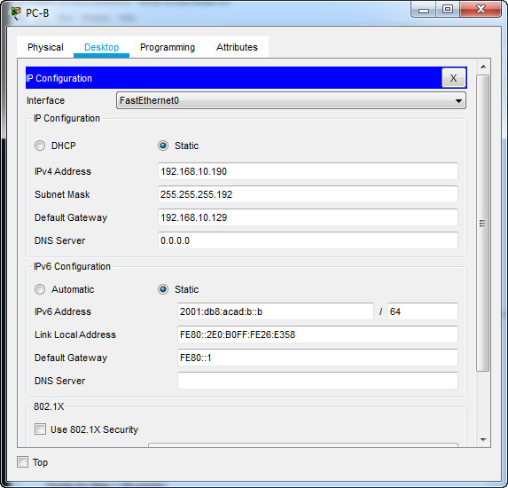
C:\>ipconfig /all

FastEthernet0 Connection:(default port)

Connection-specific DNS Suffix..:
Physical Address................: 00E0.B026.E358
Link-local IPv6 Address.........: FE80::2E0:B0FF:FE26:E358
IPv6 Address....................: 2001:DB8:ACAD:B::B
IPv4 Address....................: 192.168.10.190
Subnet Mask.....................: 255.255.255.192
Default Gateway.................: FE80::1
192.168.10.129
DHCP Servers....................: 0.0.0.0
DHCPv6 IAID.....................:
DHCPv6 Client DUID..............: 00-01-00-01-A3-07-96-75-00-E0-B0-26-E3-58
DNS Servers.....................: ::
0.0.0.0
Points for Step 1 (28 points):
Enter score here.
Points for Step 2 (15 points):
Enter score here.
Points for Step 3 (2 points):
Enter score here.
Instructor Sign-off Part 4:
Instructor Sign-off
Total Points for Part 3 (45 points)
Enter score here.

Part 4: Test and Verify End-to-End Connectivity
- Total points: 15
- Time: 10 minutes
Use the ping command to test IPv4 and IPv6 connectivity between all network devices.
Note: If pings to host computers fail, temporarily disable the computer firewall and retest.
Use the following table to methodically verify connectivity with each network device. Take corrective action to establish connectivity if a test fails:
From | To | Protocol | IP Address | Ping Results | Points
PC-A | R1 G0/0/0 | IPv4 | 192.168.10.129 | success | 1 point
PC-A | R1 G0/0/0 | IPv6 | 2001:DB8:ACAD:B::1 | success | 1 point
PC-A | R1 G0/0/1 | IPv4 | 192.168.10.1 | success | 1 point
PC-A | R1 G0/0/1 | IPv6 | 2001:DB8:ACAD:A::1 | success | 1 point
PC-A | S1 VLAN 1 | IPv4 | 192.168.10.2 | success | 1 point
PC-A | S1 VLAN 1 | IPv6 | 2001:db8:acad:a::2 | success | 1 point
PC-A | PC-B | IPv4 | 192.168.10.190 | success | 1 point
PC-A | PC-B | IPv6 | 2001:DB8:ACAD:B::B | success | 1 point
PC-B | R1 G0/0/0 | IPv4 | 192.168.10.129 | success | 1 point
PC-B | R1 G0/0/0 | IPv6 | 2001:DB8:ACAD:B::1 | success | 1 point
PC-B | R1 G0/0/1 | IPv4 | 192.168.10.1 | success | 1 point
PC-B | R1 G0/0/1 | IPv6 | 2001:DB8:ACAD:A::1 | success | 1 point
PC-B | S1 VLAN 1 | IPv4 | 192.168.10.2 | success | 1 point
PC-B | S1 VLAN 1 | IPv6 | 2001:db8:acad:a::2 | success | 1 point
In addition to the ping command, what other command is useful in displaying network delay and breaks in the path to the destination? (1 point)
tracert or traceroute
Instructor Sign-off Part 4:
Instructor Sign-off
Total points for Part 4 (15 points):
Enter score here.

Part 5: Use the IOS CLI to Gather Device Information
- Total points: 10
- Time: 10 minutes

Step 1: Issue the appropriate command to discover the following information: show version
Description | Command | Points
Router Model | blank | 1/3 point
IOS Image File | blank | 1/3 point
Total RAM | blank | 1/3 point
Total Flash Memory | blank | 1/3 point
Configuration Register | blank | 1/3 point
CLI Command Used | blank | 1/3 point

Step 2: Enter the appropriate CLI command needed to display the following on R1:
Command Description | Command | Points
Display a summary of important information  about the IPv4 interfaces on R1. | blank | 1 point
Display the IPv4 routing table. | blank | 1 point
Display the Layer 2 to Layer 3 mapping of  addresses on R1. | blank | 1 point
Display detailed IPv4 information about  interface G0/0/0 on R1. | blank | 1 point
Display the IPv6 routing table. | blank | 1 point
Display a summary of IPv6 interface  addresses and status. | blank | 1 point
Display information about the devices  connected to R1. Information should include  Device ID, Local Interface, Hold time,  Capability, Platform, and Port ID. | blank | 1 point
Save the current configuration so it will be  used the next time the router is started. | blank | 1 point
Instructor Sign-off Part 5:
Instructor Sign-off
Total points for Part 5 (10 points):
Enter score here.

Part 6: Cleanup
NOTE: DO NOT PROCEED WITH CLEANUP UNTIL YOUR INSTRUCTOR HAS GRADED YOUR SKILLS EXAM AND HAS INFORMED YOU THAT YOU MAY BEGIN CLEANUP.
Unless directed otherwise by the instructor, restore host computer network connectivity, and then turn off power to the host computers.
Before turning off power to the router and switch, remove the NVRAM configuration files (if saved) from both devices.
Disconnect and neatly put away all LAN cables that were used in the Final.

Router Interface Summary Table
Router Model | Ethernet Interface #1 | Ethernet Interface #2 | Serial Interface #1 | Serial Interface #2
1800 | Fast Ethernet 0/0  (F0/0) | Fast Ethernet 0/1  (F0/1) | Serial 0/0/0 (S0/0/0) | Serial 0/0/1 (S0/0/1)
1900 | Gigabit Ethernet 0/0  (G0/0) | Gigabit Ethernet 0/1  (G0/1) | Serial 0/0/0 (S0/0/0) | Serial 0/0/1 (S0/0/1)
2801 | Fast Ethernet 0/0  (F0/0) | Fast Ethernet 0/1  (F0/1) | Serial 0/1/0 (S0/1/0) | Serial 0/1/1 (S0/1/1)
2811 | Fast Ethernet 0/0  (F0/0) | Fast Ethernet 0/1  (F0/1) | Serial 0/0/0 (S0/0/0) | Serial 0/0/1 (S0/0/1)
2900 | Gigabit Ethernet 0/0  (G0/0) | Gigabit Ethernet 0/1  (G0/1) | Serial 0/0/0 (S0/0/0) | Serial 0/0/1 (S0/0/1)
4221 | Gigabit Ethernet 0/0/0  (G0/0/0) | Gigabit Ethernet 0/0/1  (G0/0/1) | Serial 0/1/0 (S0/1/0) | Serial 0/1/1 (S0/1/1)
4300 | Gigabit Ethernet 0/0/0  (G0/0/0) | Gigabit Ethernet 0/0/1  (G0/0/1) | Serial 0/1/0 (S0/1/0) | Serial 0/1/1 (S0/1/1)
Note: To find out how the router is configured, look at the interfaces to identify the type of router and how many interfaces the router has. There is no way to effectively list all the combinations of configurations for each router class. This table includes identifiers for the possible combinations of Ethernet and Serial interfaces in the device.
The table does not include any other type of interface, even though a specific router may contain one. An example of this might be an ISDN BRI interface. The string in parenthesis is the legal abbreviation that can be used in Cisco IOS commands to represent the interface.

